**Machine Learning Algorithms**

**Sai Triveni Kottapalli**

**ID - C00313481**

**K-Means:**

1. **Business Understanding:**

* **Objective**: Group similar data points without predefined labels, forming kk clusters.
* **Reasoning**: Useful for market segmentation, pattern discovery, or any scenario requiring automatic grouping of unlabelled data.

1. **Data Understanding:**

* Explored a dataset suitable for unsupervised learning.
* Checked for outliers and skewed distributions that might impact clustering results.
* Noted that features should be numeric for distance calculations.

1. **Data Preparation:**

* Cleaned and imputed missing data where necessary.
* Scaled or normalized features to ensure each feature contributes equally to the distance metric.

1. **Modelling:**

* Implemented **K-Means** using Scikit-learn’s KMeans class.
* Selected an initial kk (number of clusters) and iterated to find a local minimum of within-cluster variance.
* Experimented with different values of k using methods like **silhouette analysis**.

1. **Evaluation:**

* Used metrics such as **silhouette score** to assess cluster quality.
* Examined cluster centroids and sizes to understand each cluster’s characteristics.
* Validated the results by checking if the clusters made intuitive sense for the business use case.

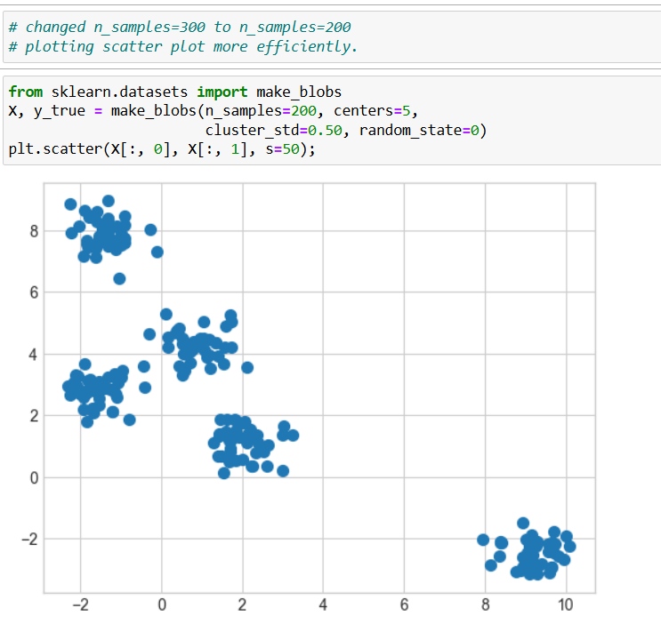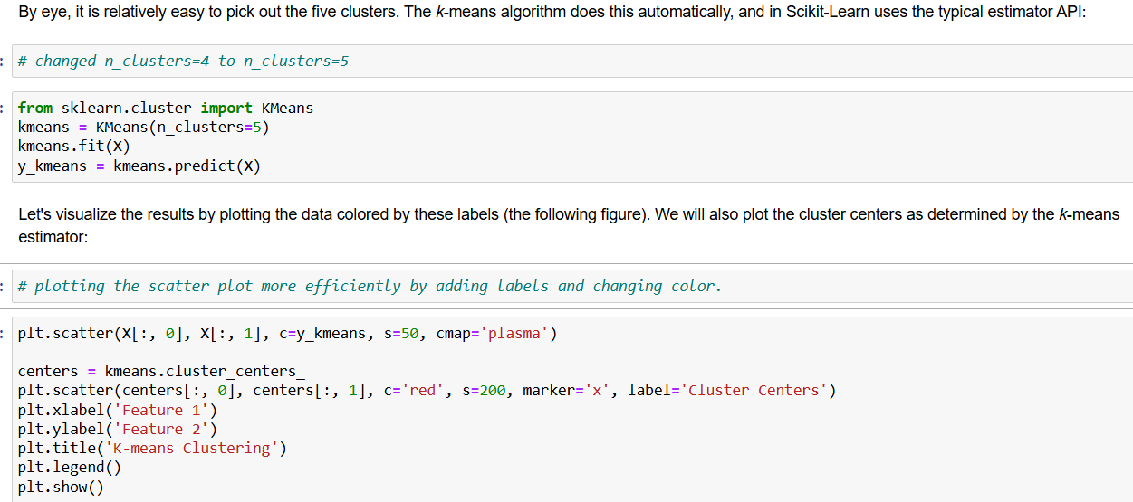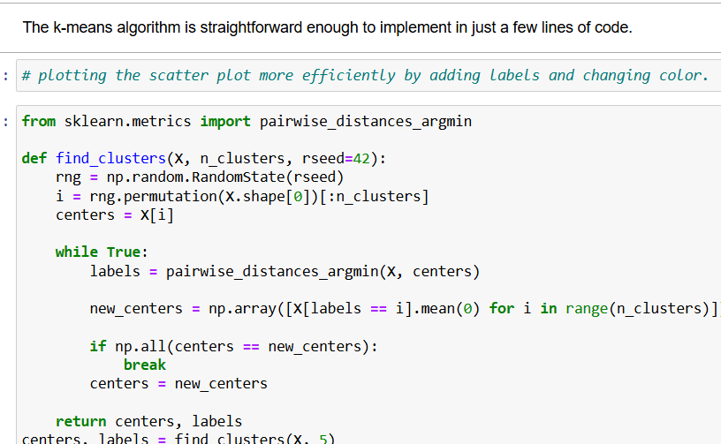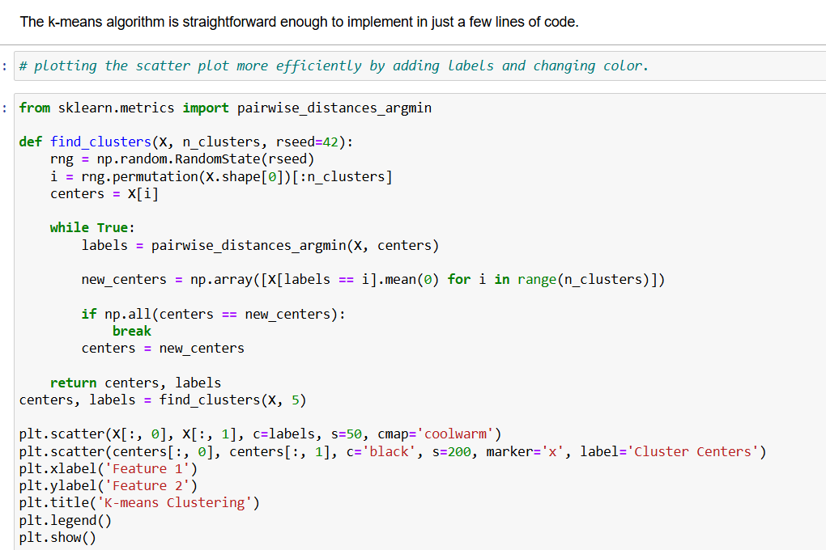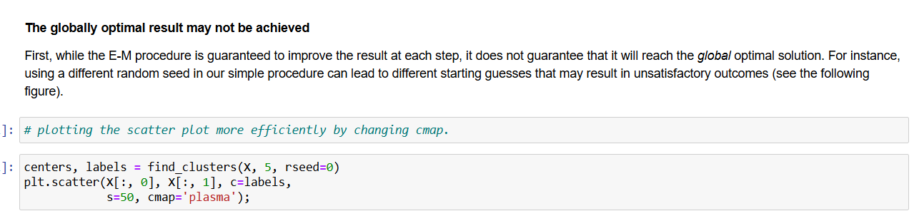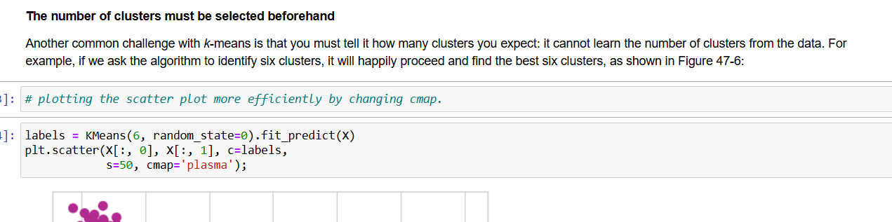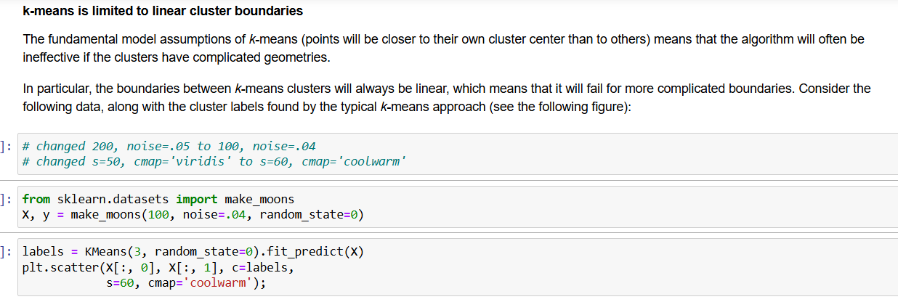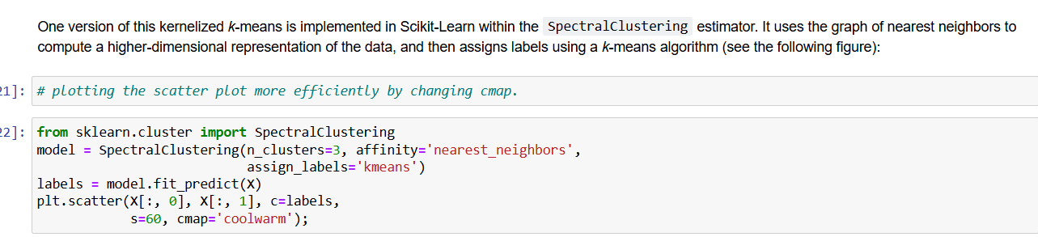

**Linear Regression:**

1. **Business Understanding:**

* **Objective**: Predict a continuous value.
* **Reasoning**: Ideal when you suspect a mostly linear relationship between features and the target.

1. **Data Understanding:**

* Analysed a dataset with numerical predictors and a continuous target variable.

1. **Data Preparation:**

* Scaled or normalized features (e.g., using StandardScaler) to stabilize the regression process.
* Engineered new features to capture non-linear relationships.

1. **Modelling:**

* Utilized a **Linear Regression** model (Scikit-learn’s LinearRegression).
* Fit the model by minimizing the sum of squared errors (Ordinary Least Squares).
* Experimented with polynomial regression for more complex patterns.

1. **Evaluation:**

* Used metrics like **R²**, **MSE**, and **MAE**.
* Created residual plots to check for patterns.
* Interpreted coefficients to understand each feature’s impact on the target.

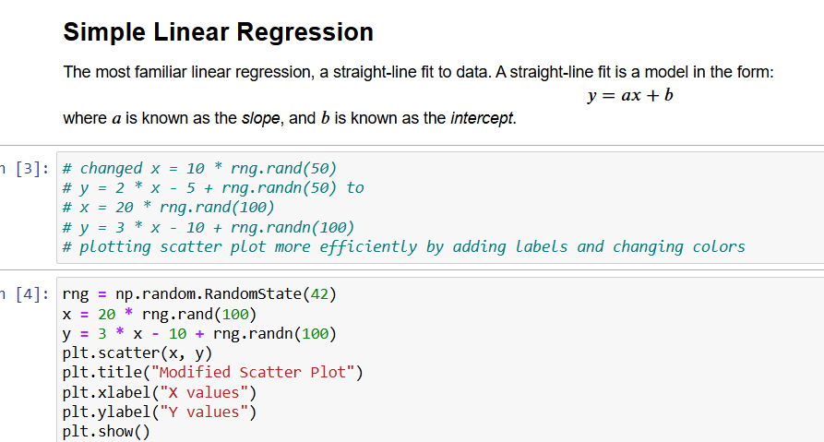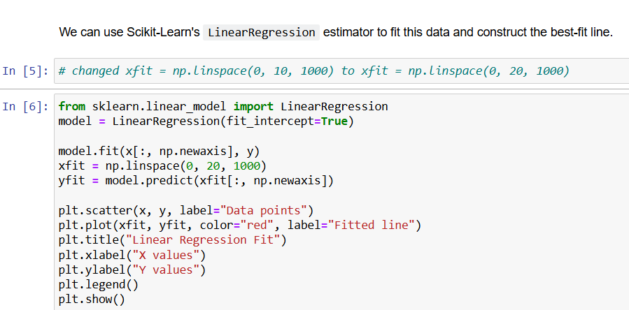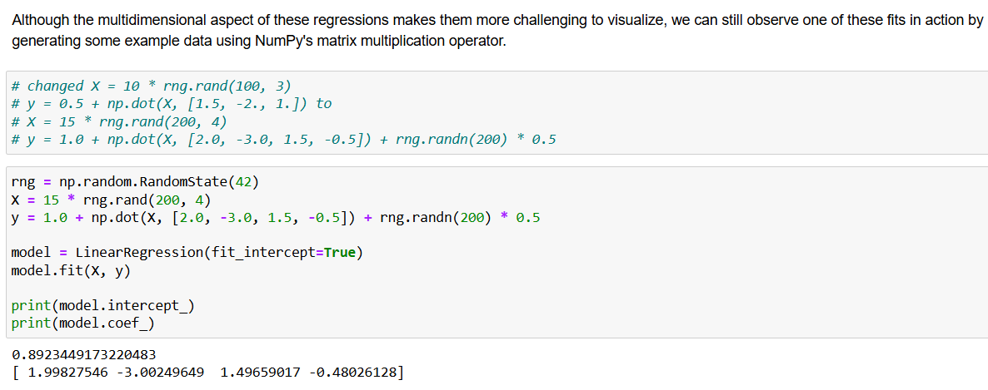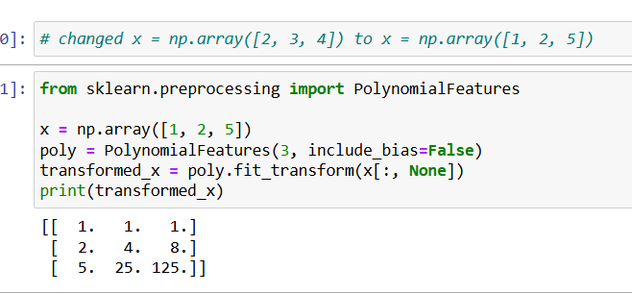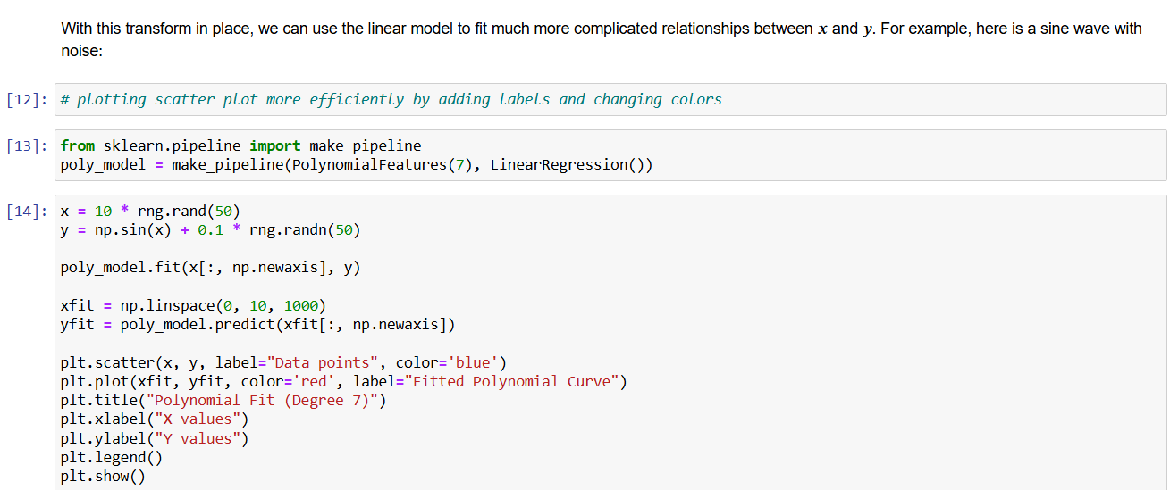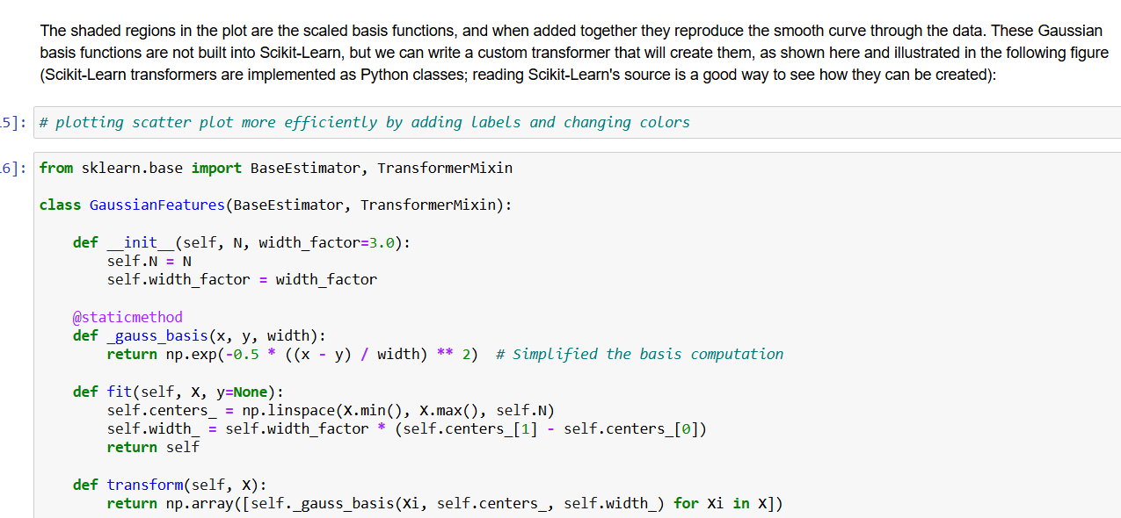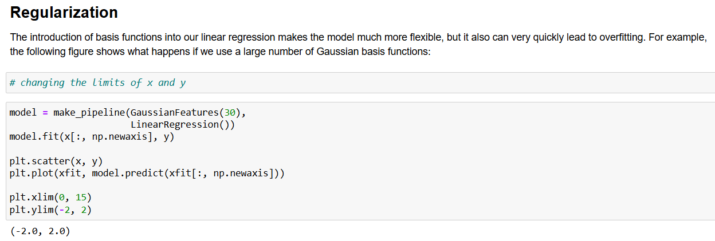

**k-Nearest Neighbors (kNN):**

1. **Business Understanding**

* **Objective**: Classify data points by “looking” at their nearest neighbors.
* **Reasoning**: Suited for problems where similar distance plays a crucial role in making predictions.

1. **Data Understanding:**

* Inspected a classification dataset with several numeric features.
* Noted that feature scales vary, making distance-based metrics sensitive if not standardized.

1. **Data Preparation:**

* Normalized or standardized features to ensure fair distance calculations.
* Split the dataset into training and test sets.
* Addressed missing values and outliers, ensuring the distance metric isn’t skewed.

1. **Modelling:**

* Implemented **kNN** using Scikit-learn (KNeighborsClassifier or KNeighborsRegressor).
* Experimented with different values of k.
* Explored Euclidean vs. Manhattan distance metrics to see which performed better.

1. **Evaluation:**

* Measured performance via **accuracy**, **precision**, **recall**, and **F1-score**.
* Performed cross-validation to optimize k.
* Visualized decision boundaries and confusion matrices for interpretability.

**Random Forests**

1. **Business Understanding**

* **Objective**: Build a robust ensemble model that reduces overfitting by averaging many decision trees.
* **Reasoning**: Good for complex datasets where a single model might not capture all interactions.

1. **Data Understanding**

* Examined a dataset with multiple features.
* Looked for missing values and identified important variables that might influence the target.

1. **Data Preparation**

* Performed feature engineering.
* Cleaned and imputed missing data.
* Split into training and test sets to avoid overfitting during training.

1. **Modelling**

* Used **RandomForestClassifier** or **RandomForestRegressor** from Scikit-learn.
* Tuned hyperparameters (e.g., number of trees, max depth, min samples split) via GridSearchCV.
* Examined out-of-bag (OOB) error if enabled, for an unbiased performance estimate.

1. **Evaluation**

* Calculated metrics like **accuracy** or **MSE**.
* Reviewed feature importances to understand key drivers in the model.
* Compared with a single decision tree to confirm performance gains and reduced overfitting.

**Decision Tree**

1. **Business Understanding**

* **Objective**: Use a tree-like structure of “if-then” splits to classify or predict a target.
* **Reasoning**: Easy to interpret and visualize, making it useful for clear decision rules.

1. **Data Understanding**

* Investigated a dataset with both numerical and categorical features.
* Checked for missing data and distribution of features that might influence splits.

1. **Data Preparation**

* Split data into training and test sets.
* Possibly pruned or combined features to reduce complexity.

1. **Modelling**

* Implemented **DecisionTreeClassifier** or **DecisionTreeRegressor** from Scikit-learn.
* Visualized the tree to interpret each split’s logic.

1. **Evaluation**

* Measured **accuracy** of the test set.
* Checked if the tree was overfitted by comparing training vs. test performance.

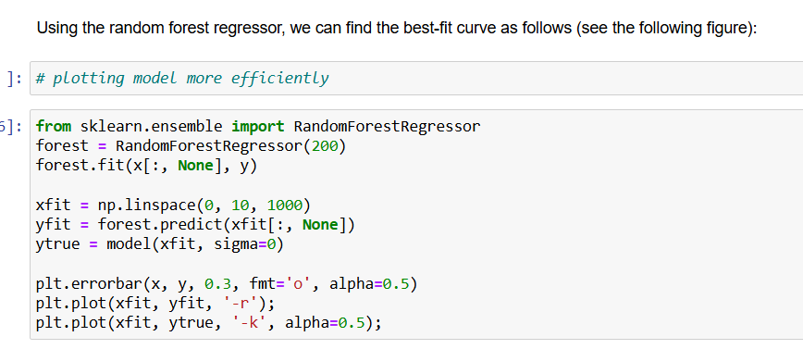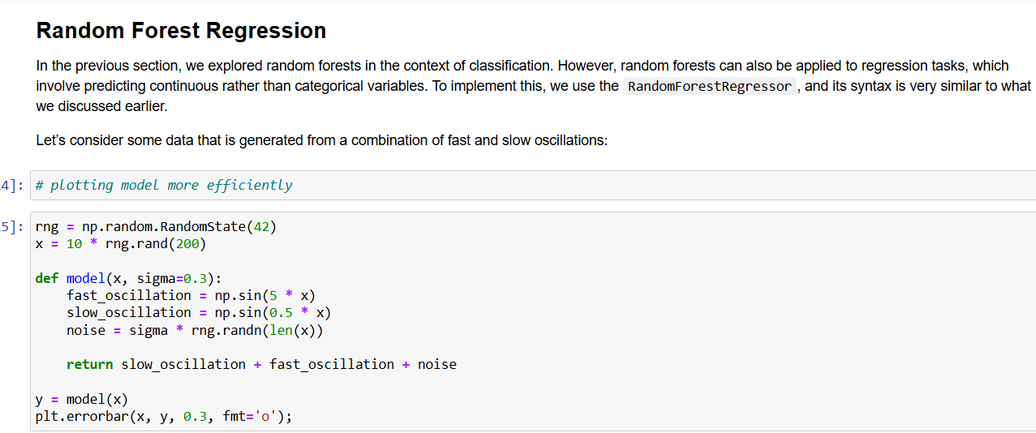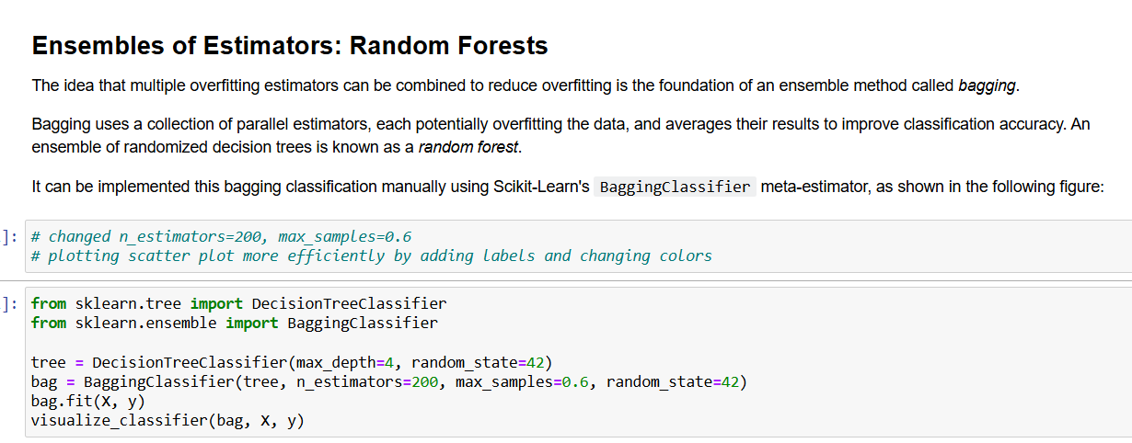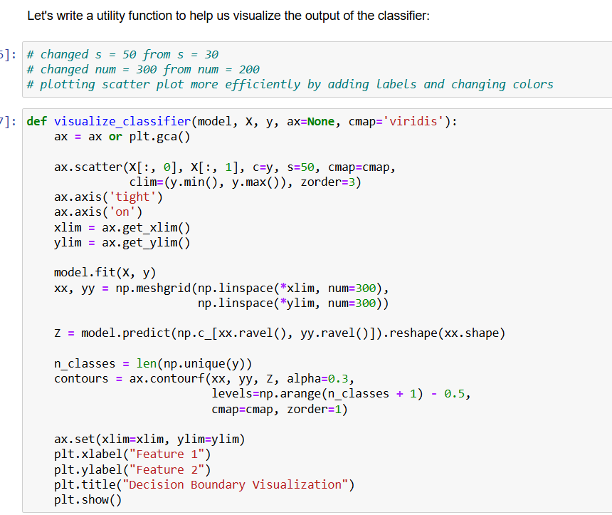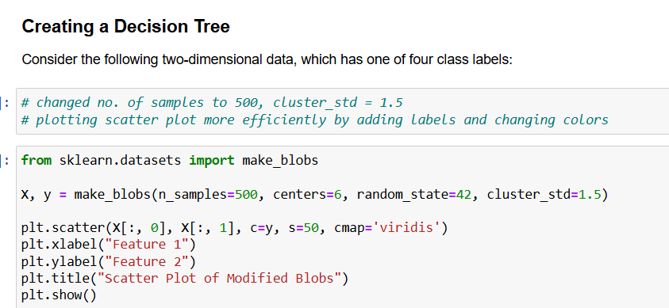

**Support Vector Machine (SVM)**

1. **Business Understanding**

* **Objective**: Separate data points or fit a hyperplane by maximizing the margin.
* **Reasoning**: Effective in high-dimensional spaces and can model complex boundaries with kernel functions.

1. **Data Understanding**

* Explored a dataset that could be for classification or regression.
* Noticed the distribution of features and whether they might be linearly separable or require a kernel.

1. **Data Preparation**

* Normalized or scaled data, because SVMs are sensitive to feature magnitude.
* Removed or handled outliers that might unduly affect margin calculations.
* Split the dataset into training and test sets.

1. **Modelling**

* Utilized **SVC** (Support Vector Classifier) from Scikit-learn.
* Tuned hyperparameters via GridSearchCV.

1. **Evaluation**

* For classification: used **accuracy**, **precision**, **recall**, and **F1-score**.
* For regression: checked **R²**, **MSE**, or **MAE**.
* Analysed decision boundaries or performance metrics to confirm the chosen kernel’s effectiveness.
* **Implementation of SVM using Iris Dataset**

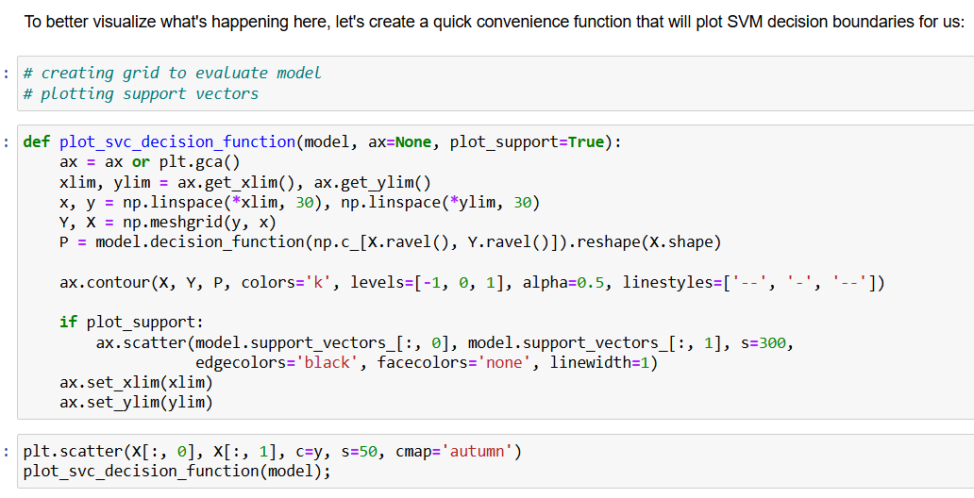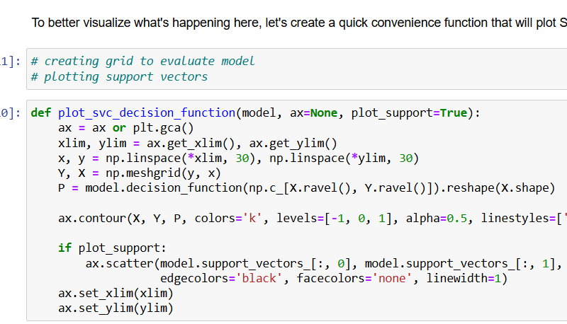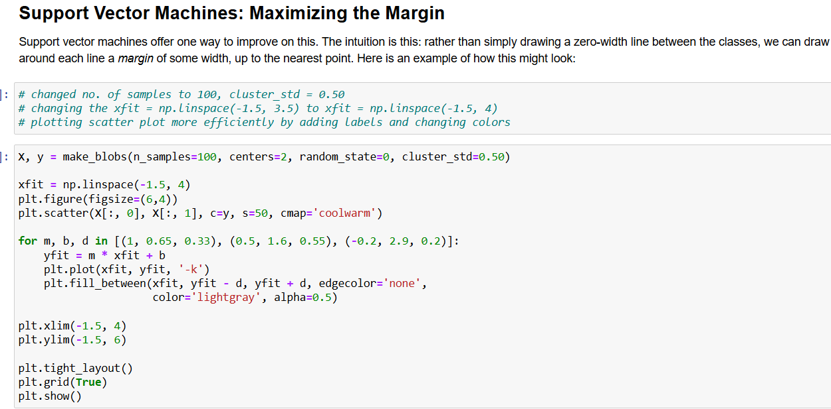

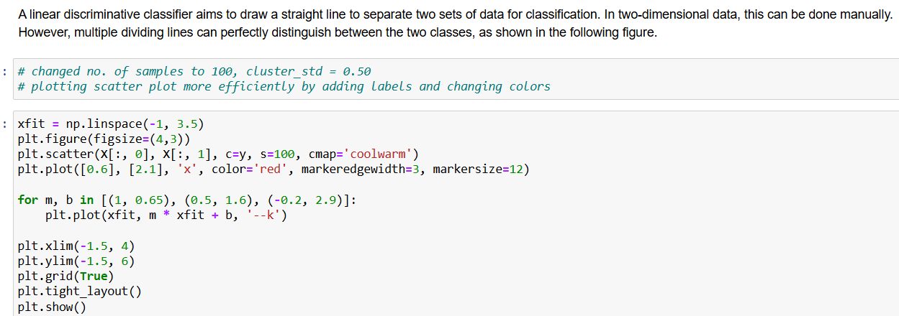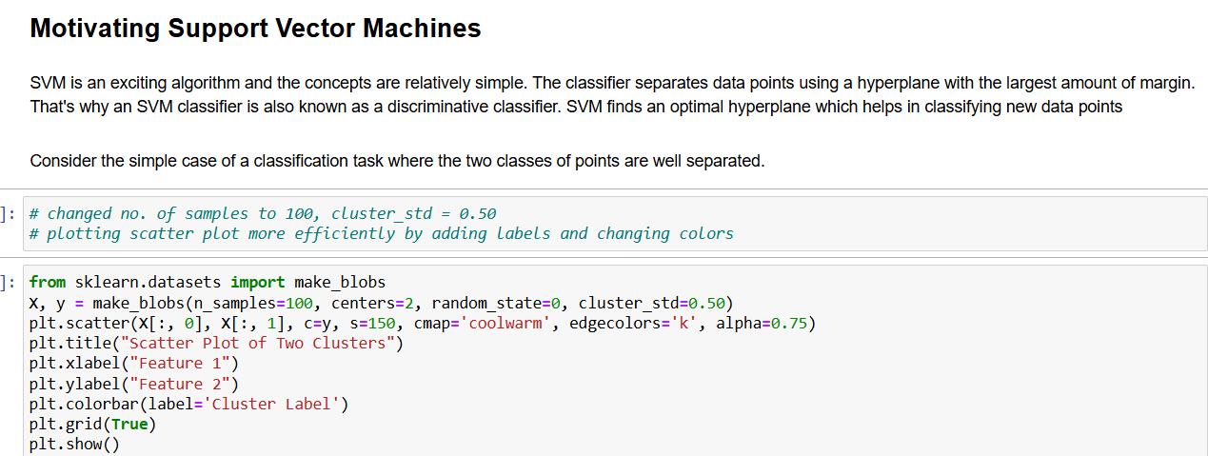 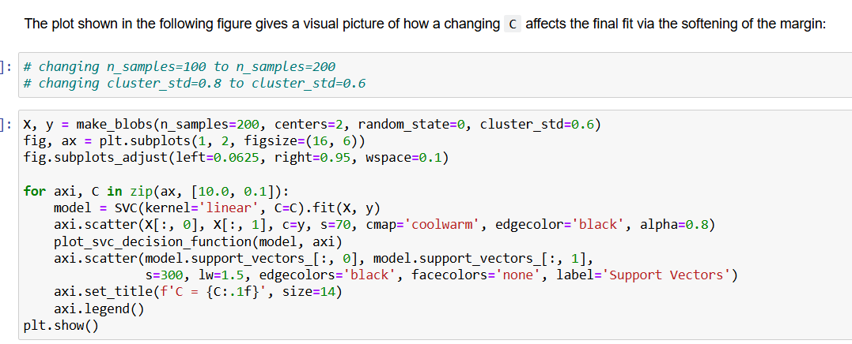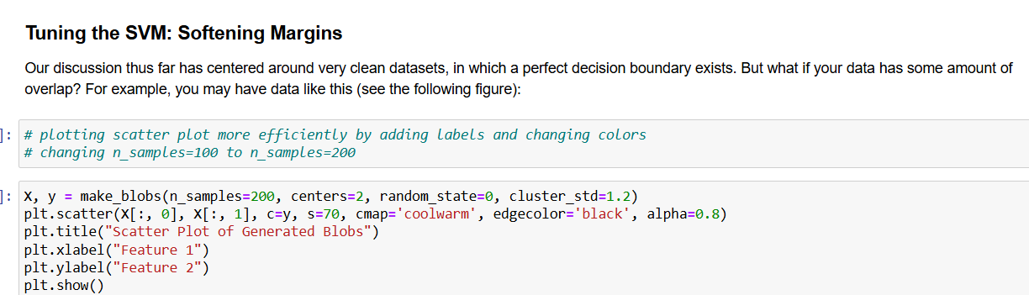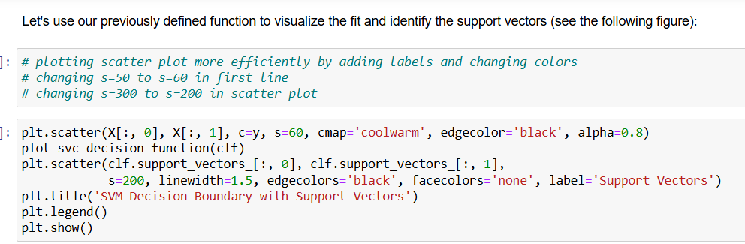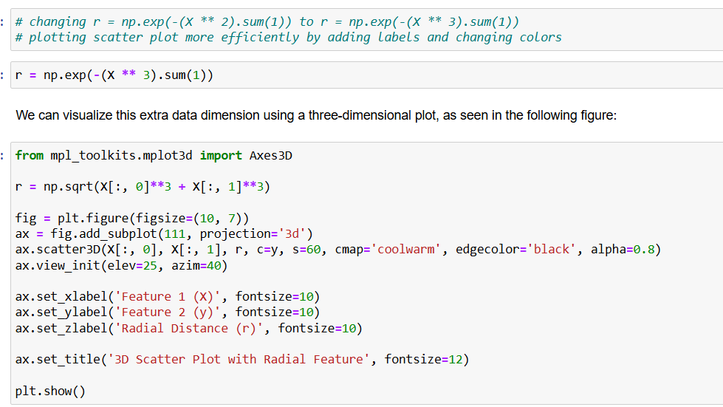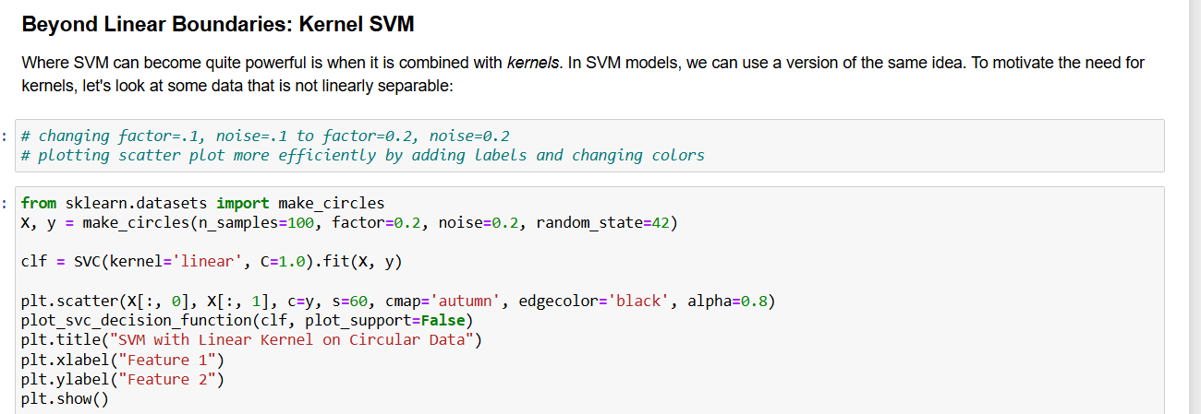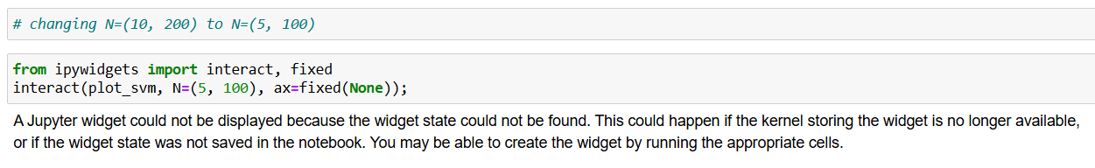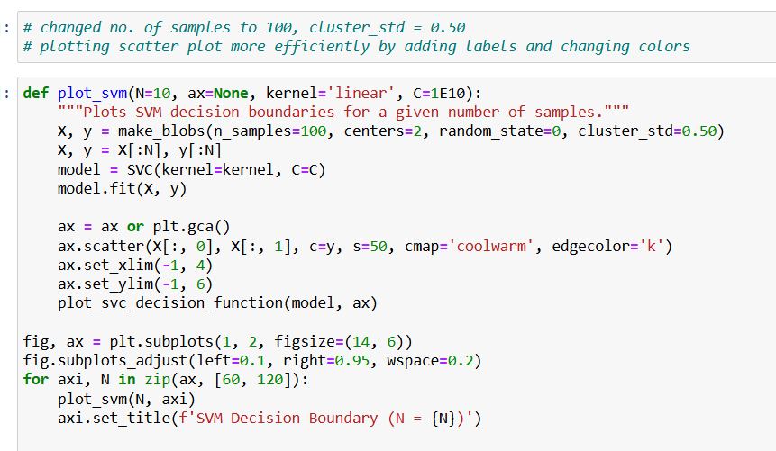

**Naive Bayes**

1. **Business Understanding**

* **Objective**: Classify data points by calculating the probability of each class based on feature values.
* **Reasoning**: Ideal for problems like spam detection, text classification, and sentiment analysis where features can be treated as independent.

1. **Data Understanding**

* Analysed a dataset with multiple features that represent counts or frequencies.
* Recognized that while the algorithm assumes feature independence, it often works well even when this assumption is not strictly true.

1. **Data Preparation**

* Transformed text or categorical data into numerical features.
* Split the data into training and test sets to ensure unbiased evaluation.

1. **Modelling**

* Implemented a Naive Bayes classifier using Scikit-learn.
* Calculated the likelihood of each feature per class and used Bayes’ theorem to determine class membership.

1. **Evaluation**

* Assessed performance using accuracy, precision, recall, and F1-score metrics.
* Analysed the confusion matrix to understand classification errors across different classes.

